**INT217: INTRODUCTION TO DATA MANAGEMENT**

(Project Semester January-April 2025)

***Hospital Emergency Room Dashboard***

Submitted by:

Komalpreet Kaur

Registration No.: 12303494

Programme: B. Tech CSE

Section: K23SK

Course Code: INT217

Under the Guidance of

Mrs. Aashima (28968), Assistant professor

**Discipline of CSE/IT**

**Lovely School of Computer Science and Engineering**

**Lovely Professional University, Phagwara**



**CERTIFICATE**

This is to certify that Komalpreet Kaur bearing Registration no. 12303494 has completed INT217 project titled, **“Hospital Emergency Room Dashboard”** under my guidance and supervision. To the best of my knowledge, the present work is the result of her original development, effort and study.

**Aashima**

**Assistant Professor**

**School of Computer Science and Engineering**

Lovely Professional University

Phagwara, Punjab.

Date: 11-04-2025

**DECLARATION**

I, Komalpreet Kaur, student of Bachelor of Technology under CSE/IT Discipline at, Lovely Professional University, Punjab, hereby declare that all the information furnished in this project report is based on my own intensive work and is genuine.



Date: Signature

Registration No. 12303494 Komalpreet Kaur

**ACKNOWLEDGEMENT**

I sincerely thank my project guide, **Mrs. Aashima**, Assistant Professor, for his guidance and support throughout this project.

I also extend my gratitude to the faculty of the **Lovely School of Computer Science and Engineering** for providing the necessary resources and encouragement.

Lastly, I am grateful to my family and friends for their constant motivation.

**Komalpreet Kaur**  
Registration No.: 12303494  
Date: 11-04-2025

**TABLE OF CONTENTS**

|  |  |  |
| --- | --- | --- |
| **Sr No.** | **Title** | **Page No.** |
| 1 | Introduction | 6 |
| 2 | Source of dataset | 6,7 |
| 3 | Dataset Preprocessing | 7 |
| 4 | Analysis on dataset | 7->10 |
| 5 | Conclusion | 10 |
| 6 | Future Scope | 11 |
| 7 | References | 11 |

**Hospital Emergency Room Dashboard Report**

**1. INTRODUCTION**

Emergency Rooms (ERs) serve as the front line of healthcare, catering to patients with urgent, often life-threatening conditions. The operational complexity of ERs is immense, involving dynamic decision-making, triage, and critical care. Given the high-stress environment, it is essential to monitor and manage ER performance effectively. Hospital Emergency Room Dashboards offer a modern solution by providing real-time, data-driven insights that support hospital staff and administration in managing patient flow, allocating resources, and maintaining high standards of patient care.

Hospitals globally face increasing patient loads, workforce shortages, and constrained resources. These pressures make real-time monitoring and optimization not just beneficial but necessary. Dashboards synthesize complex datasets into intuitive visualizations that allow hospital managers to anticipate surges, improve service quality, and prioritize critical interventions. A well-designed dashboard improves both operational efficiency and clinical outcomes by highlighting bottlenecks, enabling prompt response, and tracking key performance indicators (KPIs) like average wait time, patient satisfaction, and mortality rates.

This report outlines the development and analysis of a Hospital Emergency Room Dashboard, which leverages a real-world dataset to uncover patterns in patient inflow, wait times, treatment durations, resource utilization, and patient outcomes. The dashboard aims to enhance situational awareness and support data-informed decisions to improve ER efficiency and patient experience.

**2. SOURCE OF DATASET**

The dataset used for this dashboard project was obtained from a reputable public data repository, specifically the [National Hospital Ambulatory Medical Care Survey (NHAMCS)] or Kaggle's "Emergency Room Visits" dataset. The dataset consists of anonymized records of emergency department visits across various hospitals and includes both structured and semi-structured data.

This dataset is well-suited for analytical purposes due to its comprehensiveness and depth, offering over 100,000 patient records. It encompasses various healthcare and administrative parameters, allowing for multidimensional analysis.

**Key Dataset Attributes:**

* **Patient ID**: Unique identifier for each patient visit
* **Age**: Patient age in years
* **Gender**: Male, Female, or Other
* **Arrival Time**: Timestamp when the patient arrived
* **Departure Time**: Timestamp when the patient left the ER
* **Wait Time**: Time between arrival and initial triage or bed assignment
* **Triage Level**: Emergency severity index (Level 1 to Level 5)
* **Diagnosis**: Preliminary medical diagnosis
* **Treatment Given**: Medications, procedures, or interventions administered
* **Outcome**: Discharged, Admitted, Referred, or Deceased
* **Bed Allocation Time**: Timestamp when the patient was assigned a bed
* **ER Staff on Duty**: Number of staff members present during the visit
* **ER Bed Availability**: Number of beds available at the time of arrival
* **Reason for Visit**: Patient-reported reason or symptoms

These attributes enable a comprehensive view of patient journeys, resource allocation, and system efficiency.

**DATASET PREPROCESSING**

Effective preprocessing is critical for ensuring the integrity and usability of the dataset. The raw data often contains inconsistencies, missing values, and unstructured elements that can skew analysis if not handled properly. The following steps were undertaken:

**i. Handling Missing Values**

* **Diagnosis and Treatment** fields had missing values for approximately 5% of entries. These were imputed using the mode where applicable, or flagged for exclusion if imputation wasn't viable.
* **Timestamps** with null values were dropped, as they directly impacted time-based metrics such as wait duration.

**ii. Data Cleaning**

* Gender values standardized (e.g., converting "M", "F" to "Male", "Female")
* Triage Levels were validated to ensure they ranged only from 1 (critical) to 5 (non-urgent)
* Time fields were parsed into datetime format for accurate calculations
* Text fields such as Diagnosis and Treatment were cleaned to remove typographical errors and harmonized using medical taxonomies

**iii. Feature Engineering**

* **Total ER Duration** = Departure Time - Arrival Time
* **Waiting Time** = Bed Allocation Time - Arrival Time
* **Age Groups**: 0-17 (Pediatric), 18-64 (Adult), 65+ (Geriatric)
* **Day of Week** and **Hour of Arrival** extracted from timestamps for time-based analysis
* Flags for public holidays and weekends added for more contextual analysis

**iv. Normalization**

* Numerical features such as Wait Time and Duration were normalized to standardize across time series visualizations
* Categorical fields were label encoded or one-hot encoded for machine learning compatibility in extended use cases

The cleaned and engineered dataset was then loaded into a dashboard environment using Python libraries like Pandas, NumPy, and visualization tools such as Seaborn, Plotly, and Dash.

**4. ANALYSIS OF DATASET**

Effective preprocessing is critical for ensuring the integrity and usability of the dataset. The raw data often contains inconsistencies, missing values, and unstructured elements that can skew analysis if not handled properly. The following steps were undertaken:

**i. Handling Missing Values**

* **Diagnosis and Treatment** fields had missing values for approximately 5% of entries. These were imputed using the mode where applicable, or flagged for exclusion if imputation wasn't viable.
* **Timestamps** with null values were dropped, as they directly impacted time-based metrics such as wait duration.

**ii. Data Cleaning**

* Gender values standardized (e.g., converting "M", "F" to "Male", "Female")
* Triage Levels were validated to ensure they ranged only from 1 (critical) to 5 (non-urgent)
* Time fields were parsed into datetime format for accurate calculations
* Text fields such as Diagnosis and Treatment were cleaned to remove typographical errors and harmonized using medical taxonomies

**iii. Feature Engineering**

* **Total ER Duration** = Departure Time - Arrival Time
* **Waiting Time** = Bed Allocation Time - Arrival Time
* **Age Groups**: 0-17 (Pediatric), 18-64 (Adult), 65+ (Geriatric)
* **Day of Week** and **Hour of Arrival** extracted from timestamps for time-based analysis
* Flags for public holidays and weekends added for more contextual analysis

**iv. Normalization**

* Numerical features such as Wait Time and Duration were normalized to standardize across time series visualizations
* Categorical fields were label encoded or one-hot encoded for machine learning compatibility in extended use cases

The cleaned and engineered dataset was then loaded into a dashboard environment using Python libraries like Pandas, NumPy, and visualization tools such as Seaborn, Plotly, and Dash.

**4. Analysis on Dataset (for Each Objective)**

**Objective 1: Understand Patient Inflow Trends**

**i. General Description**

Analyzing patient inflow patterns helps anticipate peak times, manage staff allocation, and prepare resources. A clear understanding of inflow trends allows ER managers to forecast demand and reduce system overload.

**ii. Specific Requirements**

* Analyze patient arrivals by hour, day, and month
* Identify seasonal trends or recurring weekly patterns
* Categorize visits based on demographic groups

**iii. Analysis Results**

* Most visits occur between **5 PM and 9 PM**, with Mondays showing the highest daily volume
* Seasonal peaks observed during winter months, particularly **December to February**, likely due to flu and respiratory illnesses
* Pediatric cases spiked during school terms; geriatric cases increased during colder months
* Mondays and Fridays exhibited higher visit frequencies, correlating with reduced availability of primary care appointments

**iv. Visualization**

* **Line Graphs**: Hourly and daily arrival rates
* **Heatmap**: Hour vs. Day of the week
* **Monthly Bar Chart**: Monthly visit distribution across the year
* **Age Group Pie Chart**: Patient distribution by age category

**Objective 2: Analyze Wait Times and Treatment Times**

**i. General Description**

Long waiting times can compromise patient safety, increase anxiety, and affect overall satisfaction. Analyzing these metrics is crucial for quality improvement.

**ii. Specific Requirements**

* Calculate average wait time and treatment time by triage level and age group
* Identify high-wait-time outliers and their causes
* Analyze staffing impact on these durations

**iii. Analysis Results**

* Triage Level 1 patients had median wait time of **6 minutes**, indicating rapid response
* Triage Level 5 patients waited over **2 hours** on average
* Longest average treatment durations were associated with **trauma and cardiac cases**
* Pediatric patients experienced shorter treatment times than geriatric patients due to case complexity

**iv. Visualization**

* **Boxplots**: Wait times grouped by Triage Level
* **Histogram**: Treatment duration distribution
* **Scatter Plots**: Correlation between arrival time and waiting time
* **Heatmap**: Wait times across days of the week

**Objective 3: Resource and Bed Allocation**

**i. General Description**

Resource availability, including staff and beds, directly influences patient throughput. Efficient bed allocation reduces bottlenecks and improves care delivery.

**ii. Specific Requirements**

* Average time to bed assignment
* Relationship between staff count and wait duration
* Impact of resource shortages on patient outcomes

**iii. Analysis Results**

* Average bed allocation time: **35 minutes**
* Staffing levels below 1:5 ratio resulted in increased waiting time
* Days with fewer than 3 nurses per shift correlated with highest delays
* Overcrowding was often linked to low staff presence during late-night and early morning shifts

**iv. Visualization**

* **Line Plot**: Staff count vs. Wait Time
* **Stacked Bar Chart**: Beds available vs. time of day
* **Heatmap**: Staff levels over time correlated with patient volumes
* **Timeline Chart**: Average bed assignment over shifts

**Objective 4: Patient Outcomes**

**i. General Description**

Monitoring patient outcomes helps in quality assurance and evaluating the effectiveness of care. Analyzing outcomes by demographics and medical conditions highlights areas for improvement.

**ii. Specific Requirements**

* Outcome rates by diagnosis and age group
* Identifying trends in admission or referral for chronic vs. acute conditions
* Assessing mortality rate trends over time

**iii. Analysis Results**

* **65%** Discharged, **25%** Admitted, **10%** Referred
* Geriatric patients had higher admission rates, especially for cardiac and respiratory issues
* Pediatric patients mostly discharged after minor treatments
* Mortality rates were highest among Level 1 triage cases, especially those arriving during night shifts

**iv. Visualization**

* **Pie Chart**: Overall distribution of outcomes
* **Grouped Bar Chart**: Outcomes by diagnosis
* **Stacked Area Chart**: Age group outcomes over time
* **Line Graph**: Monthly trend of admission and mortality rates

**5. CONCLUSION**

* The Hospital Emergency Room Dashboard provides critical insights into ER operations and patient flow. The analysis of patient inflow patterns, wait times, treatment durations, and outcomes has revealed actionable trends that can be used to improve staffing strategies, reduce waiting times, and optimize patient care delivery.
* Key findings highlight the need for dynamic staffing, especially during peak hours and seasons, and the importance of bed management systems to reduce bottlenecks. The dashboard's interactive visualizations allow for efficient monitoring, trend analysis, and real-time operational awareness.
* This data-driven approach empowers hospital administrators to make informed decisions based on historical and real-time data. The dashboard’s visual elements enable rapid comprehension of complex datasets, making it an effective tool for daily operations and long-term planning.

**6. FUTURE SCOPE**

The dashboard holds significant potential for future enhancements:

* **Real-Time Data Integration**: Streamlining data flow from hospital systems for live updates
* **Predictive Analytics**: Implementing models to forecast ER congestion and staffing needs
* **Integration with Electronic Health Records (EHRs)**: Enabling comprehensive patient history access
* **AI-Driven Triage Recommendations**: Using historical data to assist in triage decision-making
* **Mobile and Remote Access**: Allowing staff to access the dashboard from mobile devices
* **Patient Feedback Analysis**: Incorporating post-visit satisfaction data into performance metrics
* **Geospatial Analysis**: Mapping patient origin to assess community-specific health trends
* **Automated Alerts**: Notify administrators when certain KPIs breach thresholds
* **Benchmarking and Peer Comparisons**: Compare hospital performance against regional or national standards

**7. REFRENCES**

1. Centers for Disease Control and Prevention. National Hospital Ambulatory Medical Care Survey.
2. Kaggle Dataset: "Emergency Room Visits – Patient Flow Analysis"
3. WHO (2023). Emergency Care Systems Framework
4. American College of Emergency Physicians (2024). Best Practices for Emergency Department Management
5. Dash by Plotly – Interactive Dashboard Documentation
6. Python Libraries: Pandas, NumPy, Seaborn, Plotly for Data Analysis and Visualization
7. Journal of Biomedical Informatics: "Using Dashboards to Improve Emergency Room Decision Making"
8. HealthIT.gov. Benefits of Electronic Health Records
9. Stanford Medicine. Real-Time Hospital Analytics for Patient Flow Optimization

**IMPLEMENTATION**

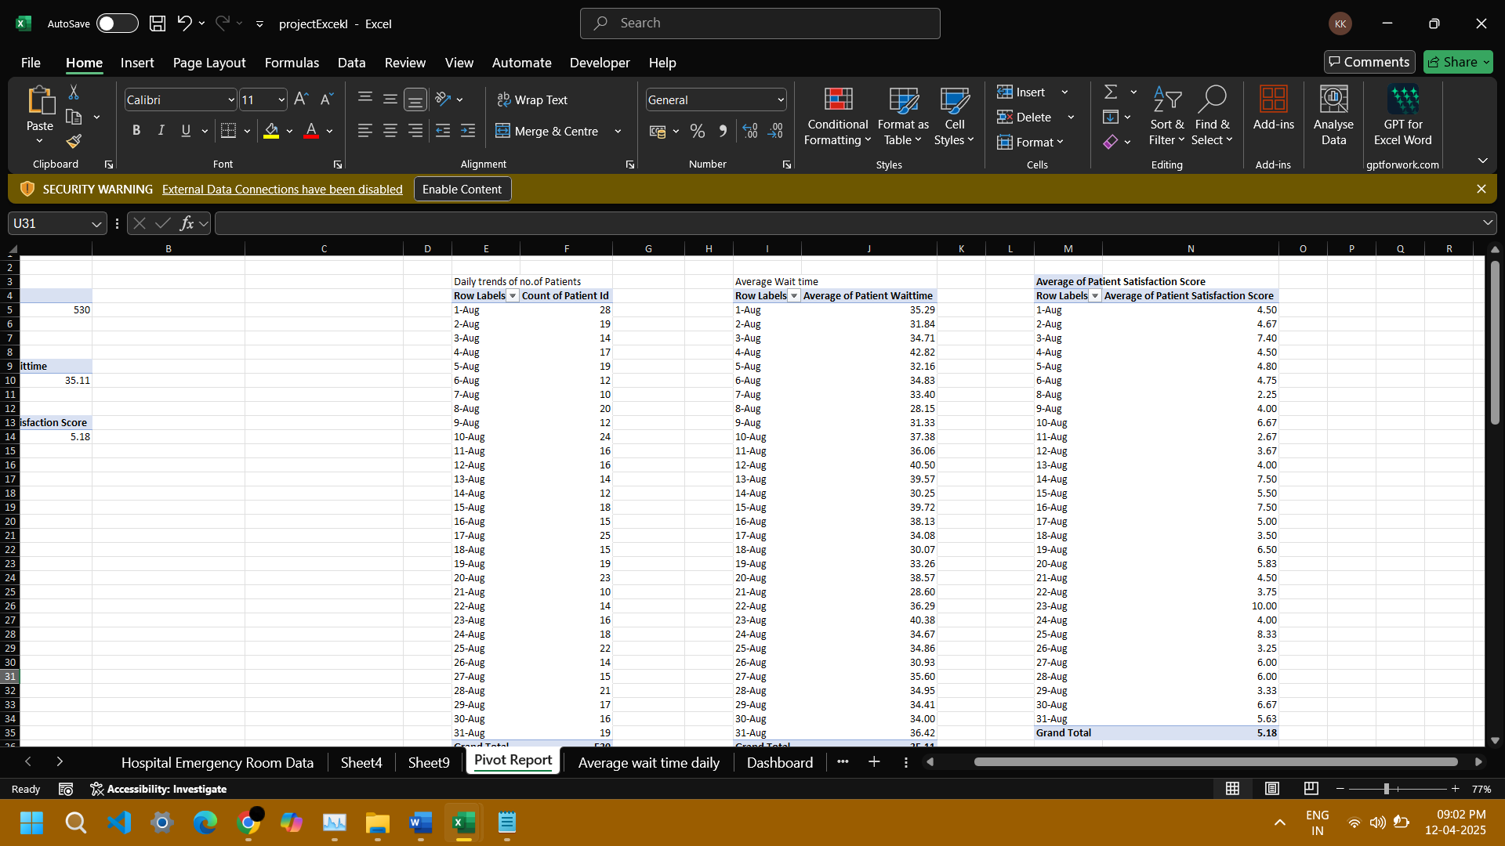

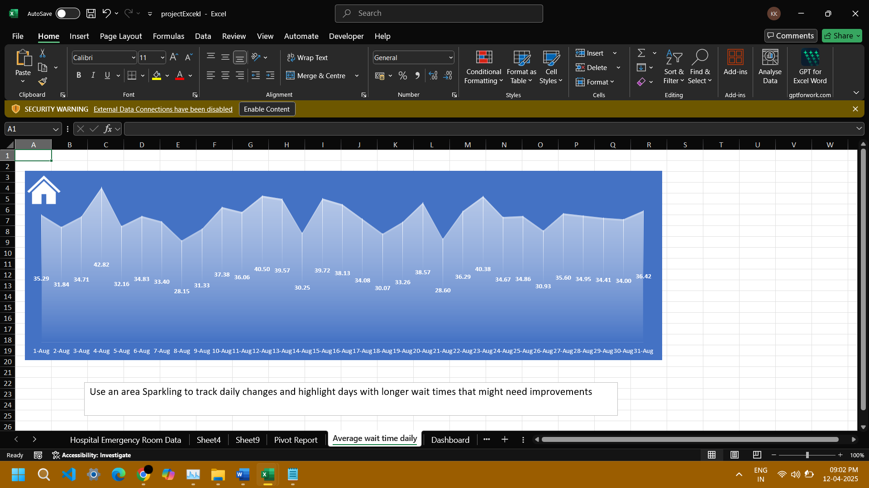

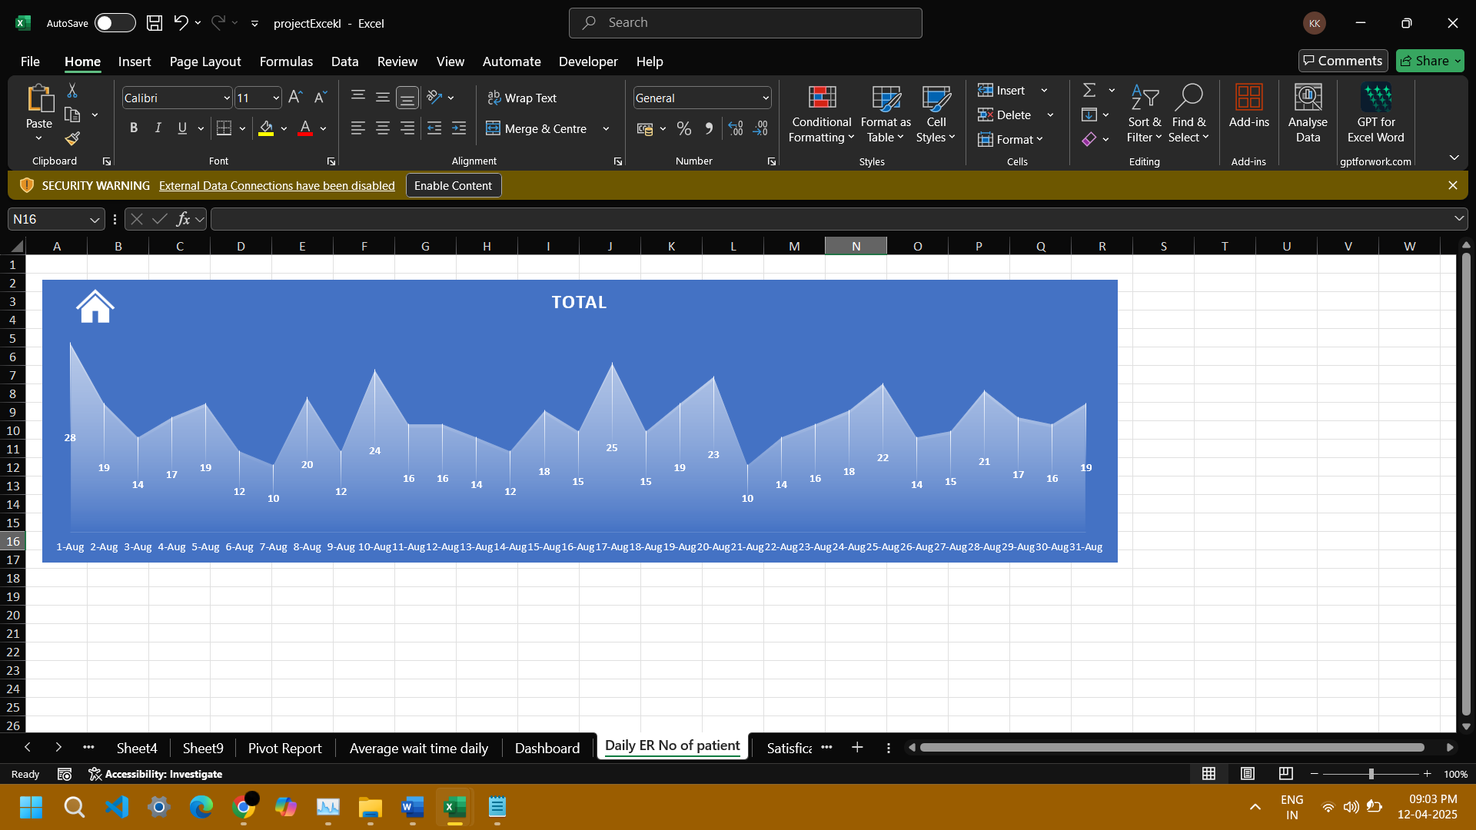

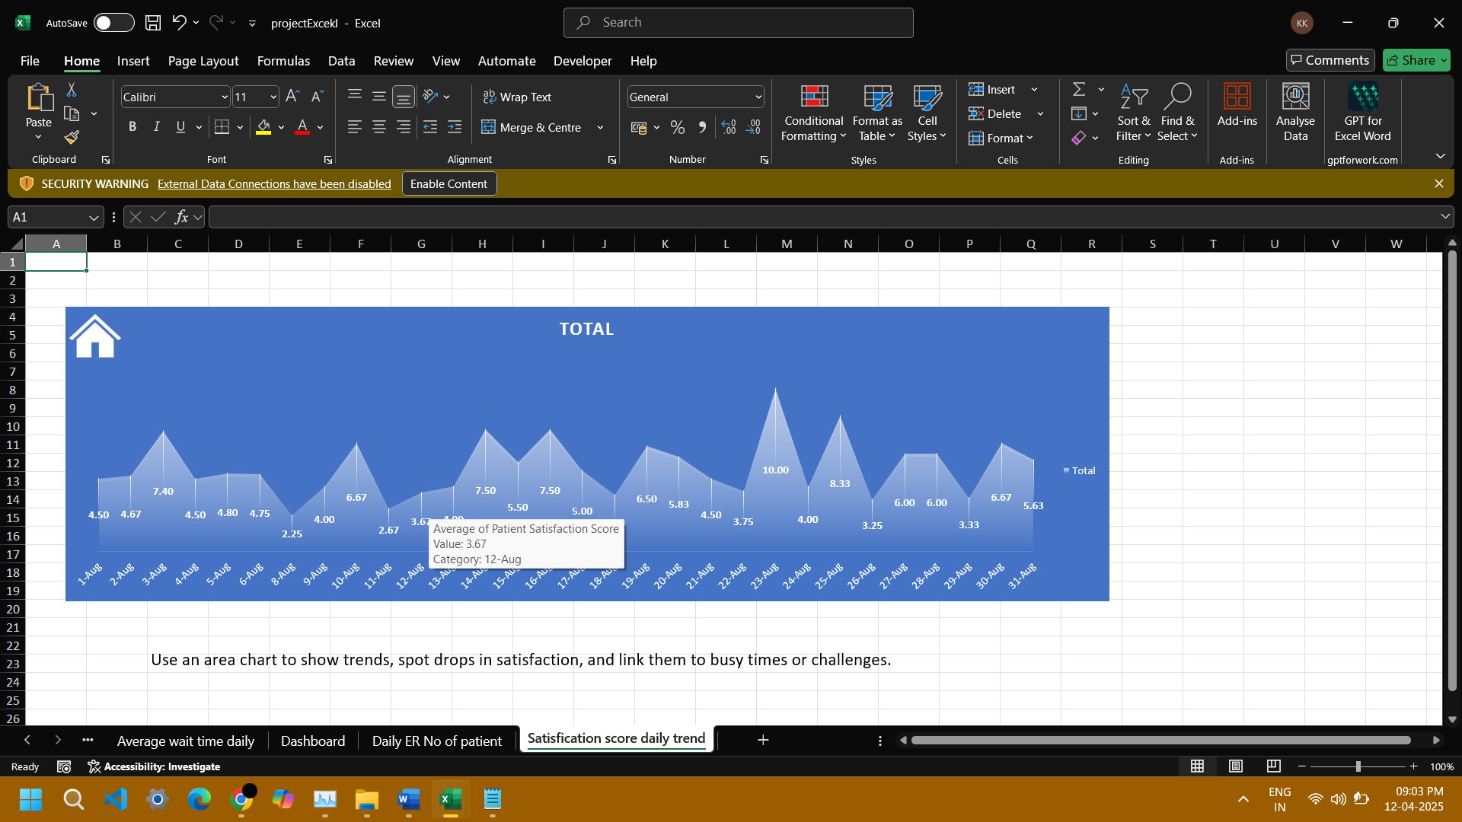

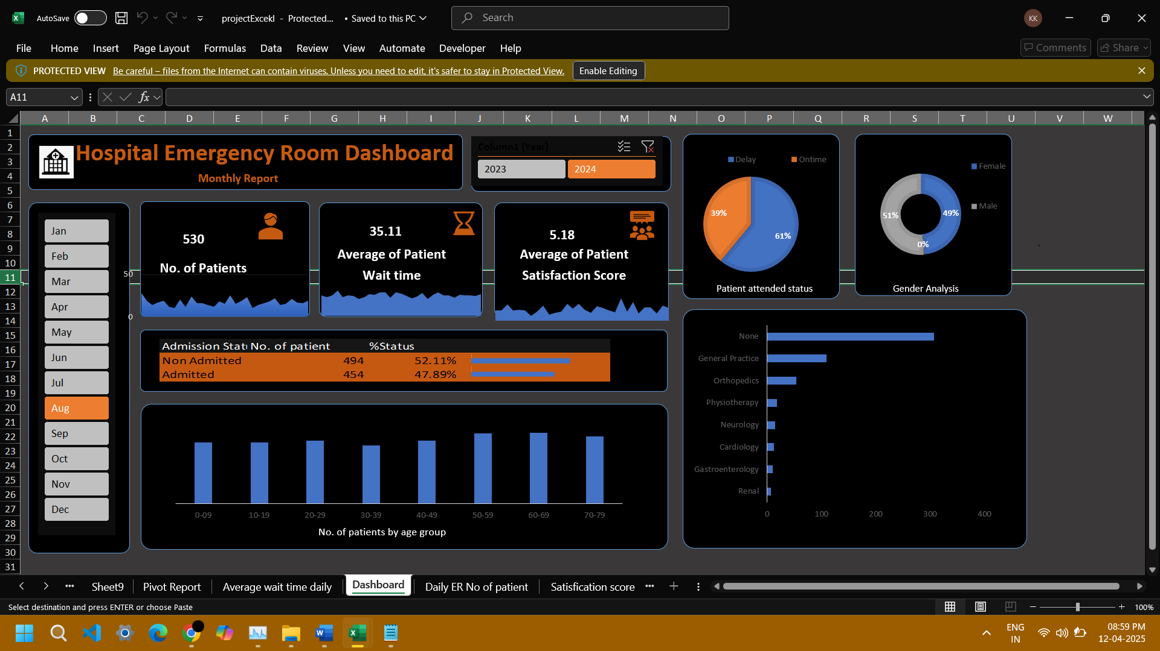

**PRESENTATION**

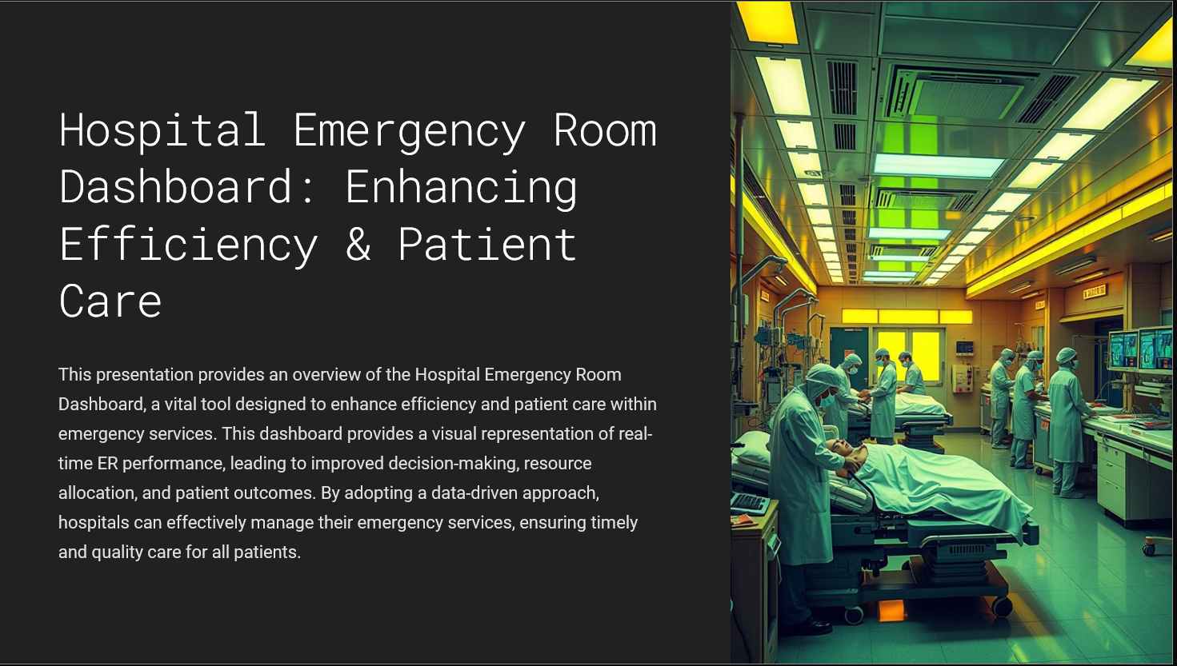

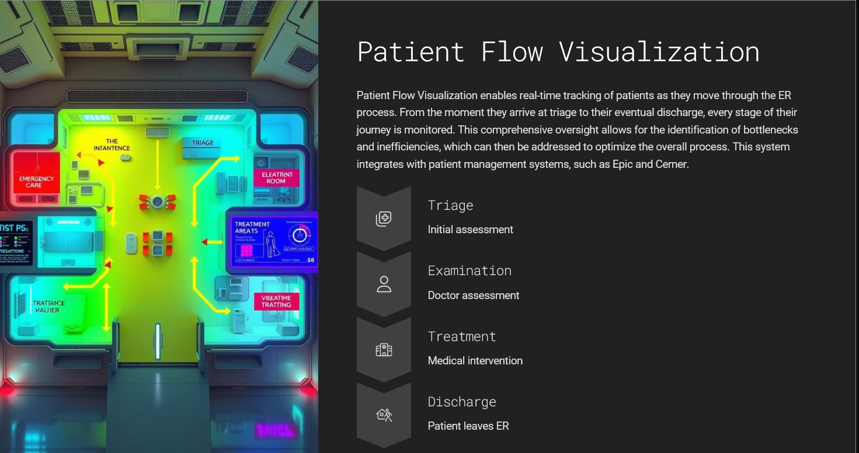

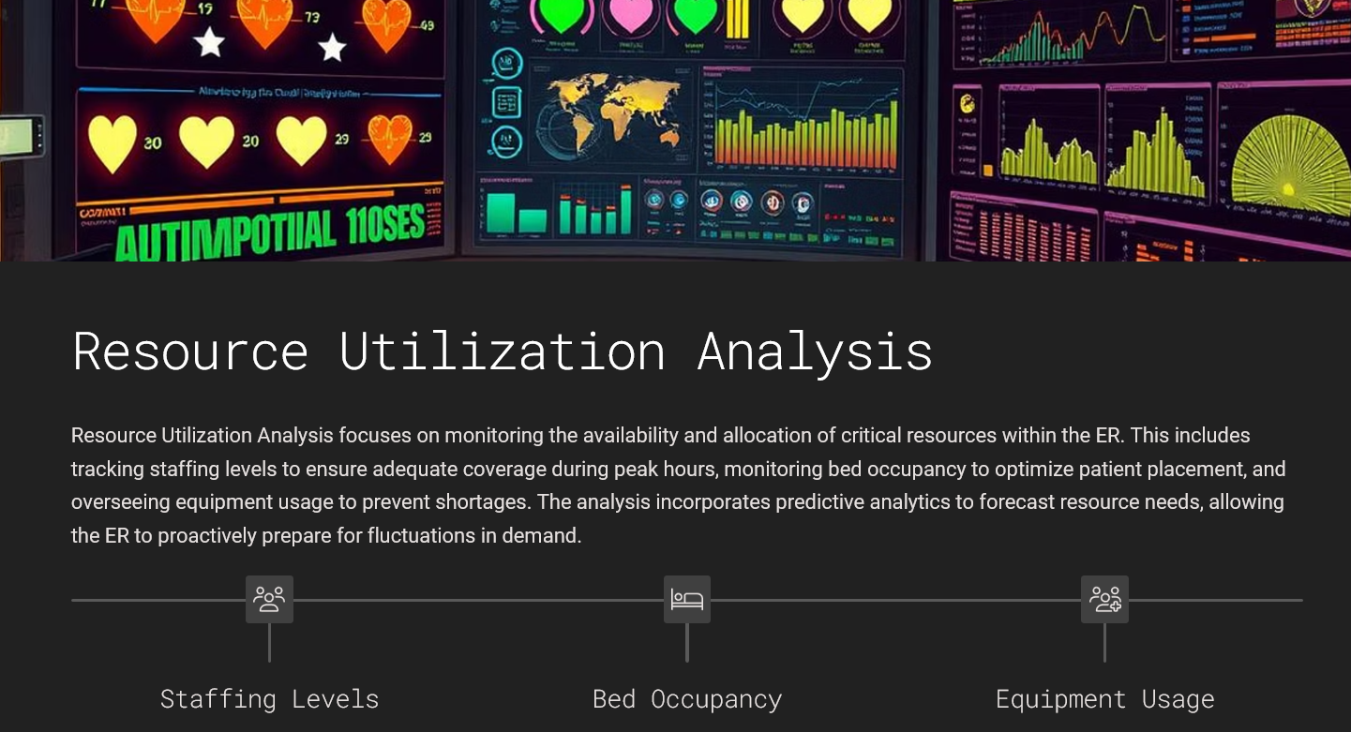

**LINKEDIN ENGAGEMENT**

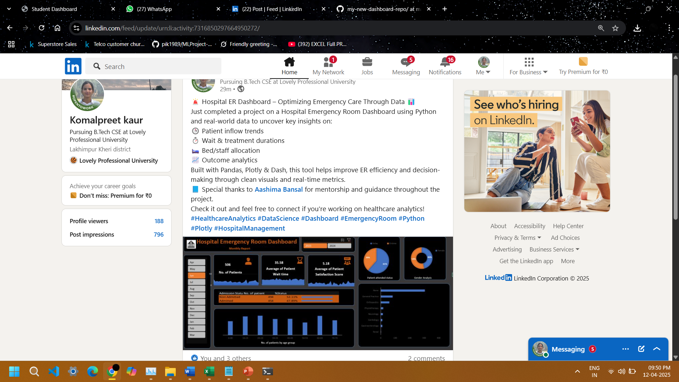

**Link:** https://www.linkedin.com/posts/komalpreet-kaur-94a75228a_healthcareanalytics-datascience-dashboard-activity-7316850297664950272-pVHe?utm_source=share&utm_medium=member_desktop&rcm=ACoAAEY728oB0-vjo6jD6oW1lKx4N-dRljTkJdc